Bushcraft Knife Safety: Get The Fundamentals Right
by PAUL KIRTLEY

Knife safety starts with choosing the right knife for the job. A folding knife can be handy in the outdoors but has an inherent weakness at the hinge. With a fixed blade there is no chance of it folding on your fingers. In choosing a fixed-blade knife, select one with a strong sheath. This protects both you and your knife.

Taking a knife out of its sheath
Believe it or not I've seen people cut themselves quite badly just removing a knife from the sheath. The thing to remember is to keep your fingers away from the cutting edge of a knife when unsheathing it.
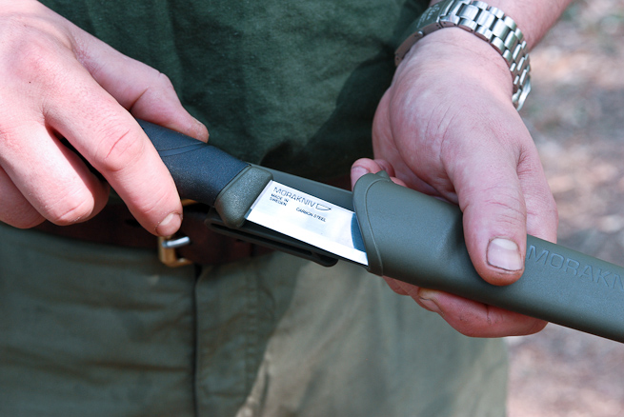
Be aware of where the cutting edge of your knife is. Photo: Ben Gray.
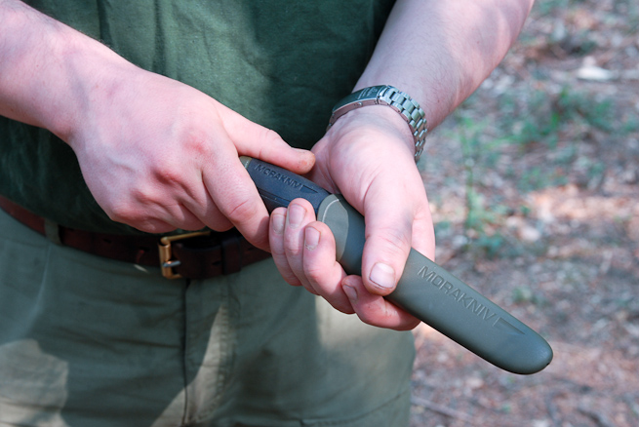
WRONG: Where not to put your fingers when unsheathing a knife. Photo: Ben Gray.
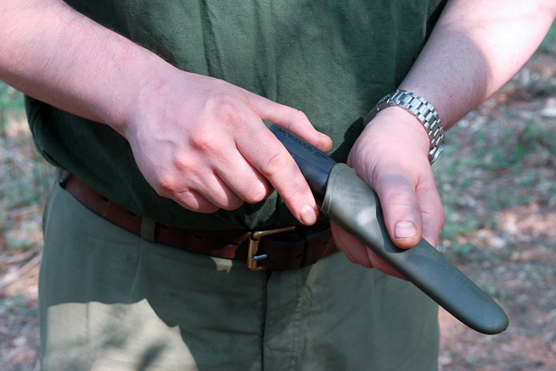
Keep your fingers well out of the way. Photo: Ben Gray.

When you are not using your knife, put it back in the sheath
The safest place for your knife is in its sheath. Don’t be tempted to stick it in a log or a tree stump for a few minutes or otherwise leave it lying around. With plenty of potential trip hazards outdoors, replace your knife in its sheath before walking even a short distance. You could cause yourself or others serious injury if you fall with a knife in your hand.
Put your knife away safely when not using it. Photo: Ben Gray
The only exception to this rule is if you have been using your knife to prepare raw meat or fish. Clean your knife before returning it to its sheath. Anticipate the need to clean your knife and have cleaning materials ready nearby.

Give yourself and others room
Don’t try to use your knife in awkward or confined spaces. Give yourself enough room to use it properly. When using your knife, leave enough room around you so that you don’t endanger other people. If someone is within an arm’s reach, they are too close.

Be aware
If you are using a knife, be aware of the movement of other people around you. They may not have noticed you are using a knife. Be aware of others using knives. If someone is using a knife nearby, stay at a safe distance.

Concentrate on what you are doing
Many cuts are due to a lack of concentration, either due to distractions or tiredness. If you aren’t able to concentrate, put your knife away until you can.

Hold your knife securely
The grip used most of the time is the forehand grip. It allows for powerful, safe cuts.
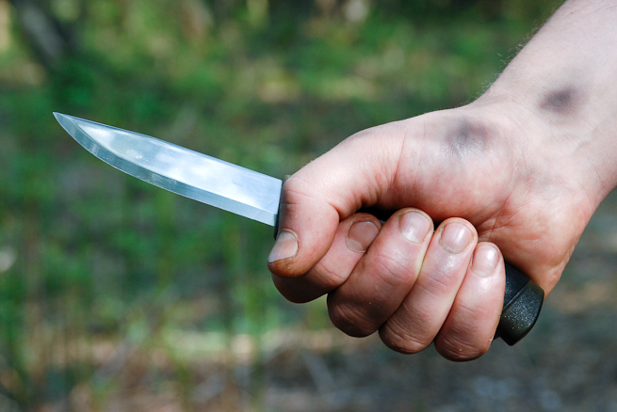
The forehand grip is secure and allows for powerful, safe cuts. Photo: Ben Gray.

Cut away from yourself
Cut away from your body and cut away from your limbs. Pay particular attention to the position of the hand that is not holding the knife.
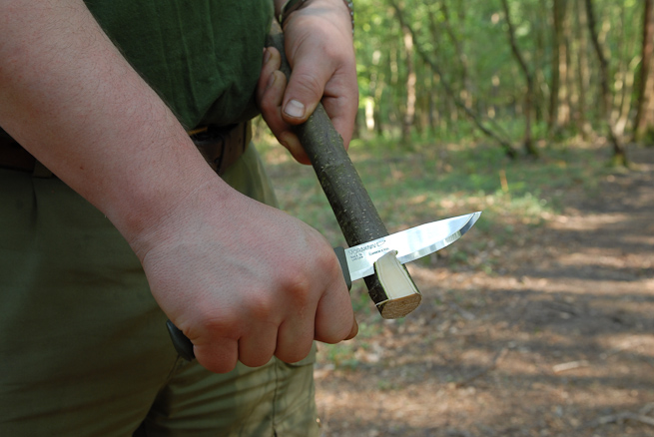
Cutting away from the body and away from the supporting hand. Photo: Ben Gray.
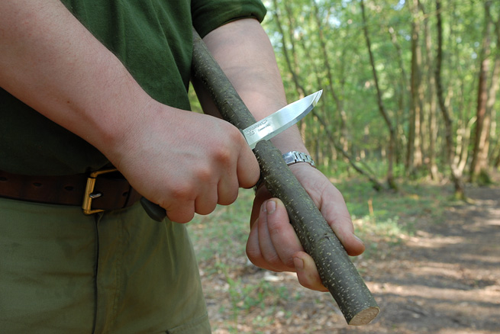
WRONG: Do not cut towards the supporting hand, even if it is on the other side of the work piece. Photo: Ben Gray.

Don’t be overambitious
Even with a sharp knife, shave off modest amounts of material with each cut of the knife. Trying to remove too much material with each cut will require excessive force, causing tired hand muscles and reduced control of the knife.
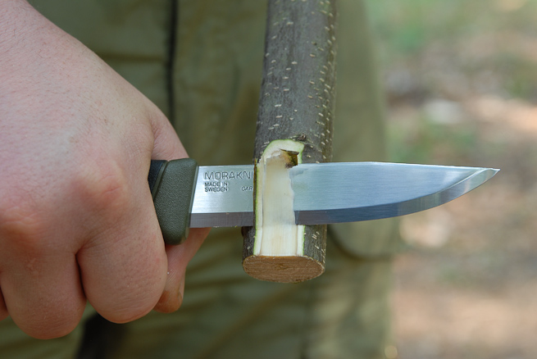
Remove modest amounts of material with control. Photo: Ben Gray.
If you need more power, work on the outside of your body and generate power by dropping your shoulder.
Safely create extra power by holding the piece like this and dropping your shoulder. Photo: Ben Gray.
If you need more stability, work onto a log, tree stump or chopping block.
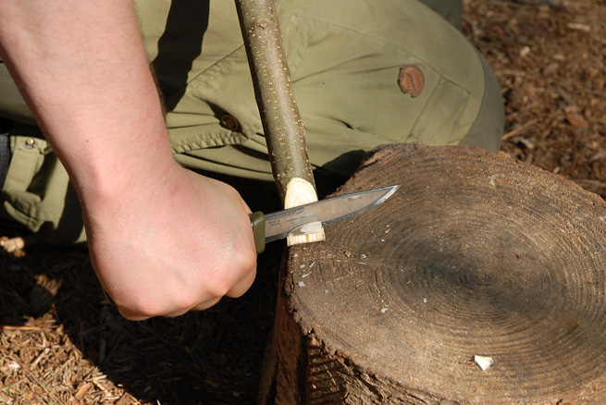
For extra support work onto a stable wooden block. Note I’m working towards the outside of my body and my legs are well out of the way. Photo: Ben Gray.

Elbows on knees
Cutting the major artery on the inside of your leg is potentially fatal. Take special care not to use a knife in a way that risks this. A particular concern is carving while sitting down. Keeping your elbows on your knees, prevents the knife coming close to your leg.
WRONG: Don’t allow yourself to work with the knife close to your inner thigh. Photo: Ben Gray.
WRONG: A slip with the knife here is potentially lethal. Photo: Ben Gray.
The right way to do it. Working with elbows on knees forces your hands away from your thighs. Photo: Ben Gray.

Think about where the knife will go if you slip
For every cut you make with your knife, consider where it will go next - not only if things go to plan but also if you slip or if you cut straight through what you are working on. Position yourself so that the next thing your knife hits isn’t you.

Listen to the little voice in your head
If you feel like you are using your knife in a risky or foolish way, then you probably are. Listen to the little voice in your head that tells you so. Then alter what you are doing so that it is safe. If you can’t figure out a way of safely achieving what you would like, ask someone with more experience for help.

How to pass a knife safely
If you need to pass a knife to someone, pass it in a way that does not put you or them at risk. Here’s how:
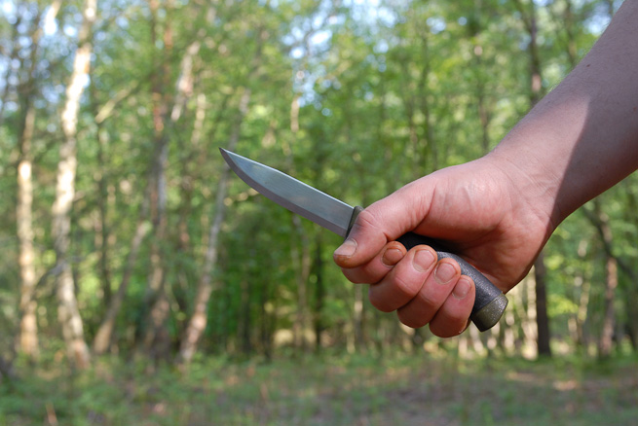
Start with the forehand grip. Photo: Ben Gray.
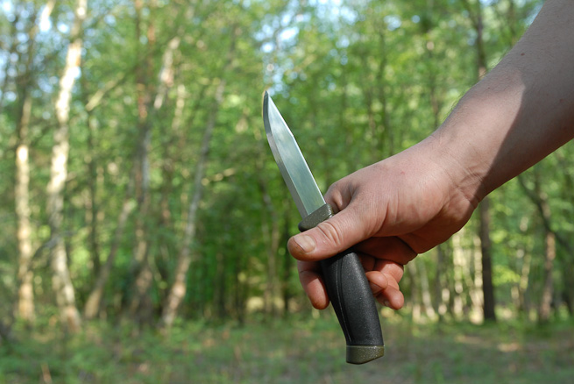
Pivot the knife in your hand. Photo: Ben Gray.
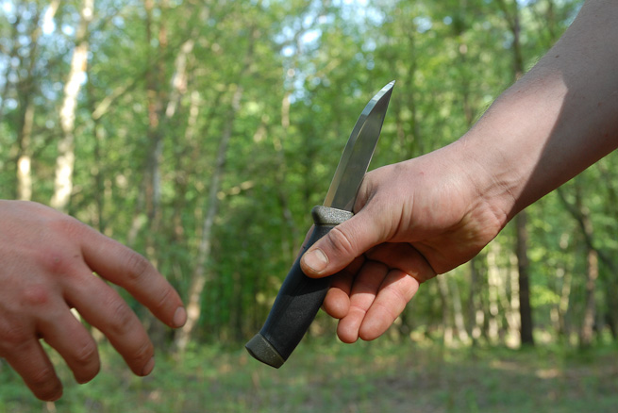
Offer the handle to the person receiving the knife. Photo: Ben Gray.
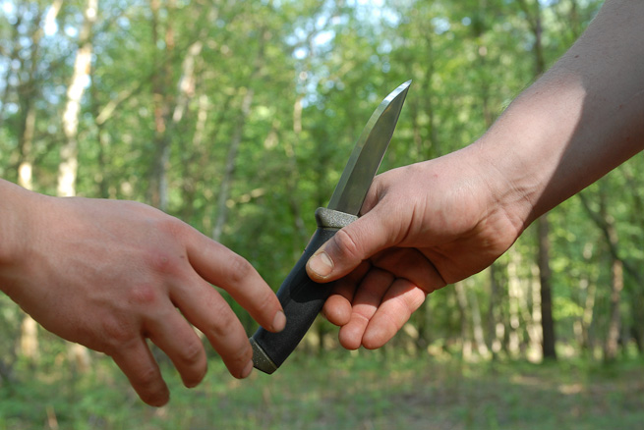
Note the point and sharp edge of the knife is away from both hands. Keep your fingers out of the way of the blade as you pass the knife. Photo: Ben Gray.
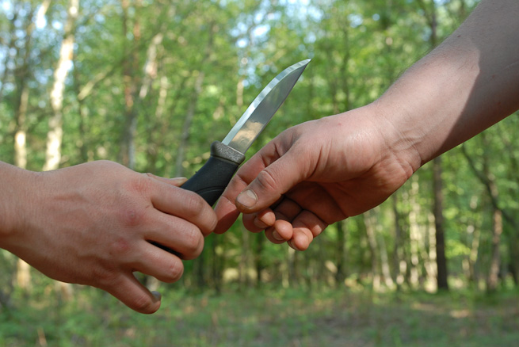
Even if the receiver snatches the knife from your hand, there is no risk of the knife cutting you. Photo: Ben Gray.

Pick up a cuts kit
If you use a knife often you will likely incur a few minor nicks. Having a small first aid kit on your person will help patch up and cuts and prevent infection.

Keep your knife sharp
A sharp knife is a safe knife. A sharp knife is predictable. You don’t need to apply excessive force when making a cut. If the knife is sharp, it cuts in a familiar way and you easily achieve what you need to. For more about sharpening see the additional resources below.

Stick to the rules
Above is laid out a straightforward set of rules for knife safety. If you apply them each time you pick up a knife, you will significantly reduce the chances of a serious cut. Even if you are an experienced knife user, however, you should never become complacent. Having cut myself many times over the years, particularly when I was young, as well as having taught thousands of people knife techniques over the years, I am more conscious of the importance of applying these rules than ever.

