HOW TO CARVE A BEAKED NOTCH FOR POT HANGERS
The simplest methods of suspending a billy can over your campfire are typically fixed in height. Simple pot hangers are little more than a straight stick with a few modifications. They are quick to set up and well suited to boiling water or cooking very simple meals.
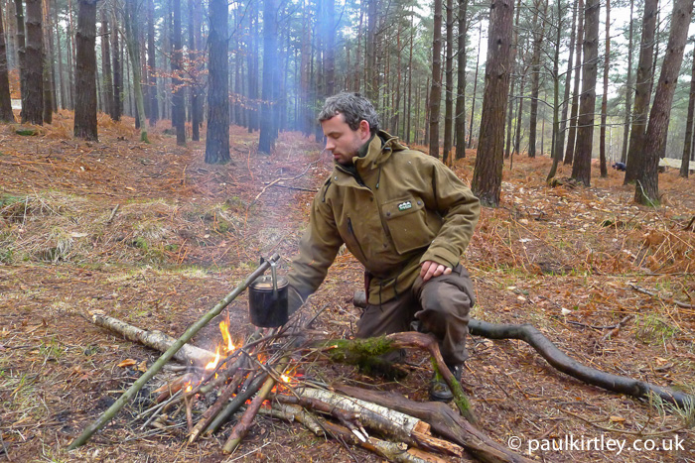An example of simple, expedient bushcraft, the pot hanger in this photo is well suited to short stays, boiling water or straightforward one-pot meals. If we are staying for longer or want more variability in the heat applied to a pot or kettle, then we need to construct a pot hanger with inherent adjustability. Photo: Paul Kirtley.

Moving Beyond Simple Pot Hangers
The downside of simple pot hangers is that they typically only afford one fixed position over the fire.
If you want to have some degree of variability in the heat you can apply to your cooking and your kettle, then you’ll need some form of adjustability in any cooking rig or crane that you are using.
Also, if you are creating a more elaborate cooking set-up, then you may want to suspend multiple pots over the fire, each at a different height.
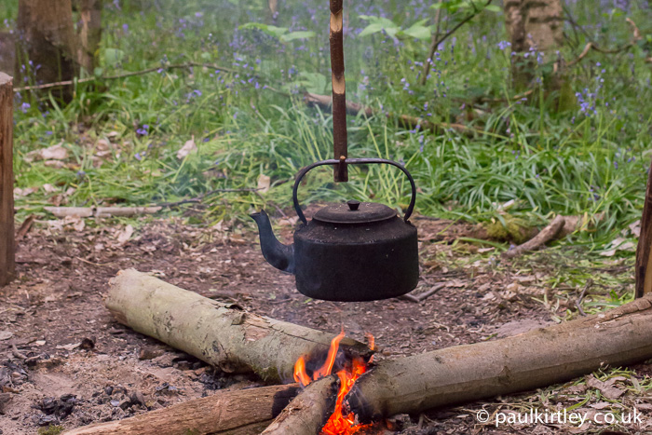It’s useful to be able to adjust the height of a pot or kettle over a campfire. The beaked notch (tutorial below) allows you a simple an robust way of achieving this. Photo: Paul Kirtley

The Beaked Notch
A useful bit of woodcraft to learn in order to construct an adjustable pot hanger that suits various camping situations is creating a beaked notch.
Creating multiple beaked notches allows the hanger to be suspended at various heights.
Thus learning the beaked notch technique enables you to create a pot hanger which is easily raised or lowered, even with the pot attached.
If a beaked notch is created and set up correctly, it can hold relatively heavy loads, remaining remarkably stable.
Material Selection For An Adjustable Pot Hanger
For suspending pots you’ll need to create a tick-shaped hanger, typically from a straight growth of woody shrub or tree that has a side branch.
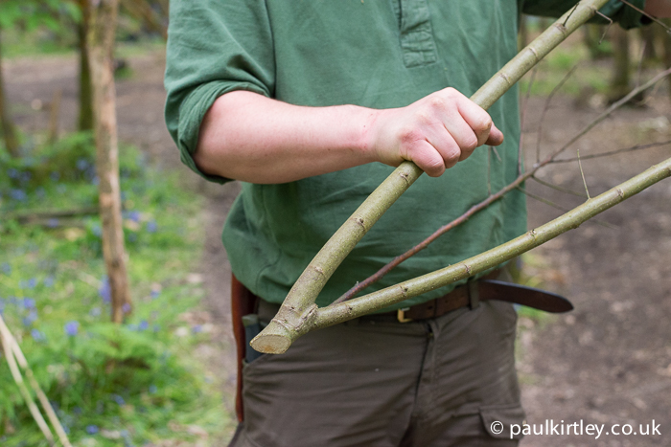 You’ll need a straight shoot with a side branch such as this.
The main shoot will be kept long and the side branch truncated near to the junction with the main shoot.
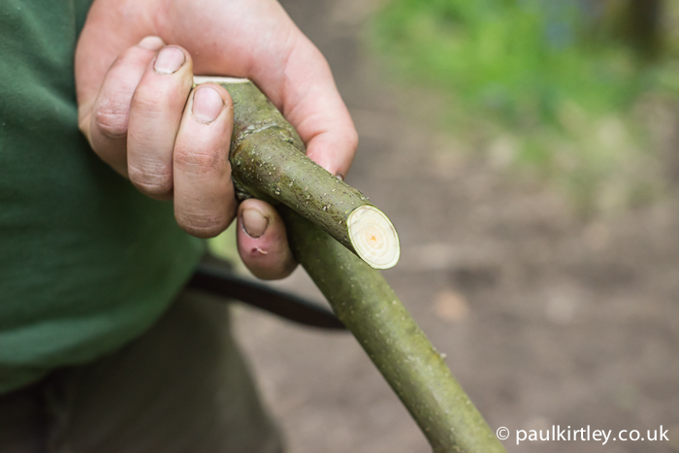
..

Carving The Beaked Notches
The beaked notches are carved into the main, straight stem of the “tick”.
Now this is where I often see a common mistake, usually by relatively inexperienced people posting photos on Facebook, Instagram and the like.
The mistake is to carve the notches on the opposite side of the stick to the hook at the base of the tick. They should, in fact, be carved on the same side. This provides much better balance and stability to the pot hanger, whatever the method of suspension.
So, now that we know which side of the stick to carve our beaked notches this is how we do it…
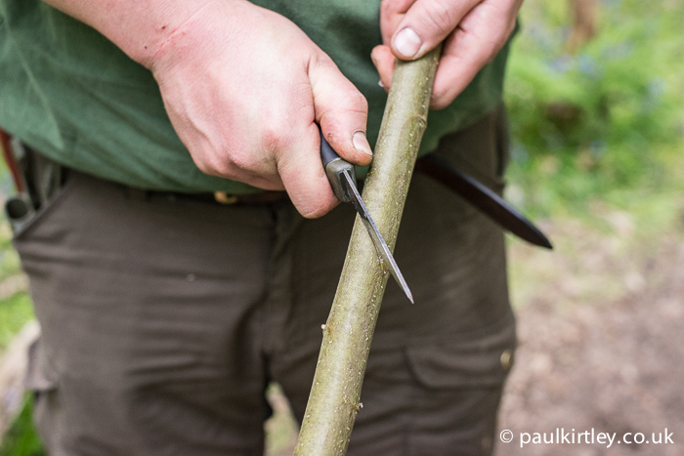You start the notch by creating an X centred on an imaginary vertical line running up the side of the stick which will have the notches. This is the first cut. Photo: Amanda Quaine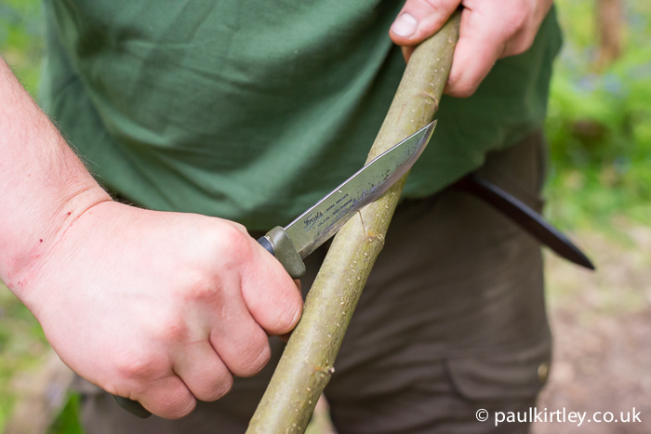The second cut completes the X. These are effectively stop cuts. 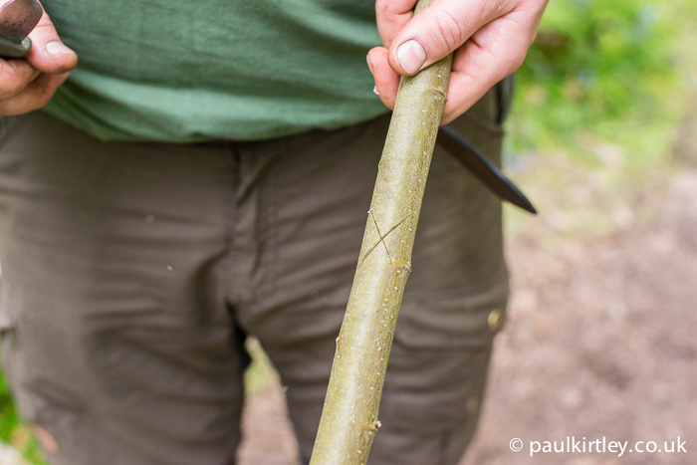 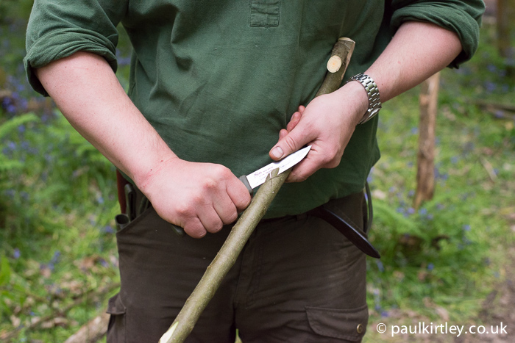Now to start removing some material. This needs to be done carefully as your stop cut is not very deep and you’ll risk slicing too far if you are not deliberate at this stage. Note the position of the hook at the bottom end of the pot hanger and that I’m cutting away from it. 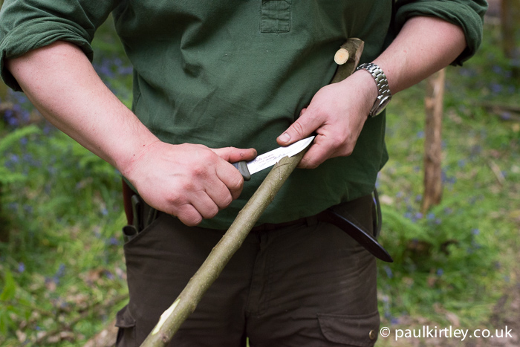I’m using the thumb of my left hand to push on the back of the knife to make a very controlled cut. 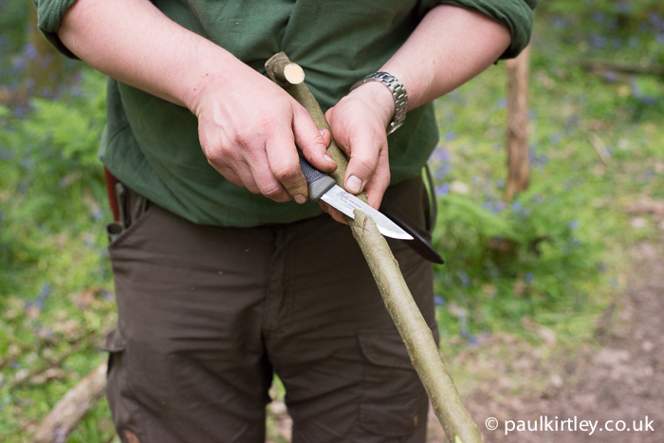Now I’m taking material off the other side of the X. Again I’m being careful not to overshoot the stop cut. The basic shape begins to form. Photo: Amanda QuaineAfter a slice or two, it’s important to deepen the stop cut as soon as possible. Then you can slice out more material with greater confidence. Photo: Amanda Quaine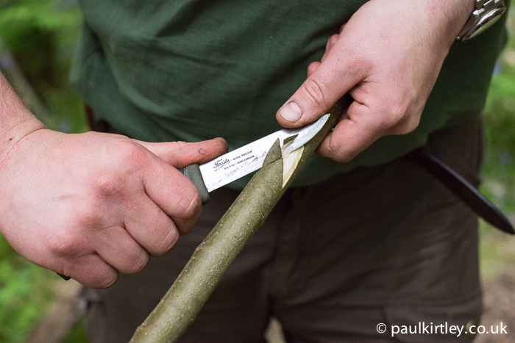Now I swap to slice material from the other side of the X. You should keep the triangle of material at the top of the X intact 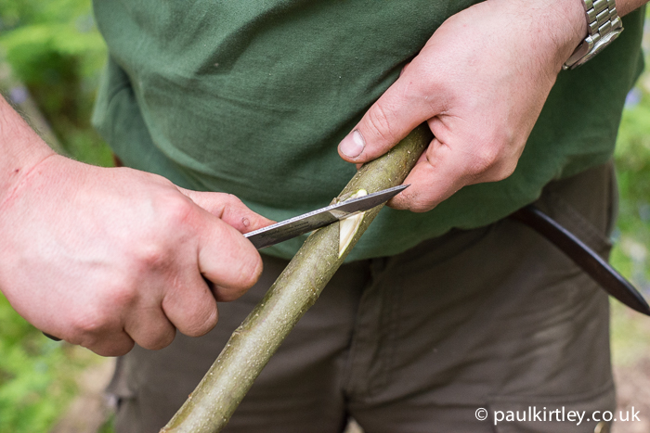 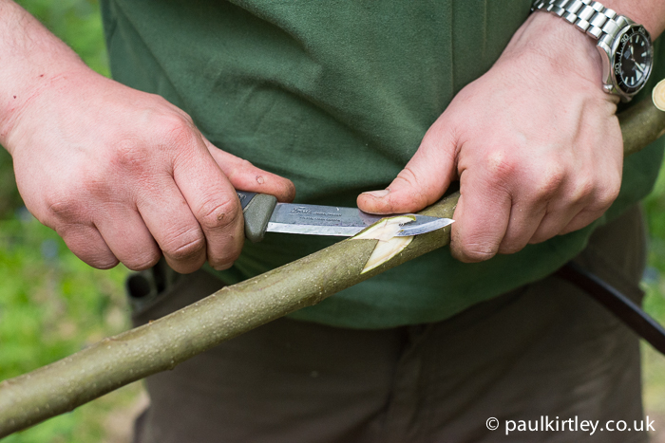By alternating this way, you’ll be able to slice material out from the area, with an increasingly solid stop cut that also forms the edge of your beaked notch.
Once the cuts become established, you can start to undercut them slightly. 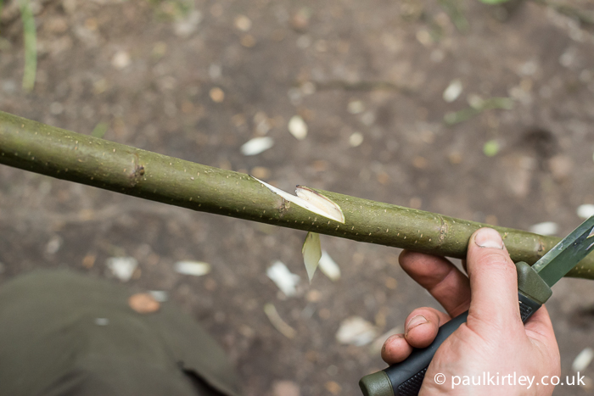 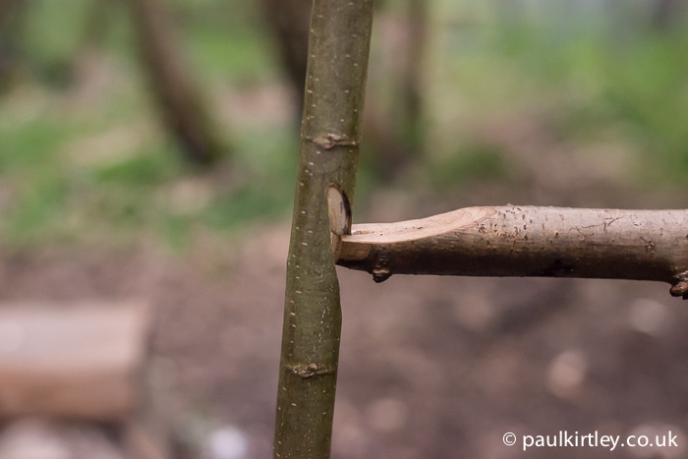How the beaked notch mates with a single-stick pot hanger set up, often referred to as a waugun stick, although there are many types of waugun. 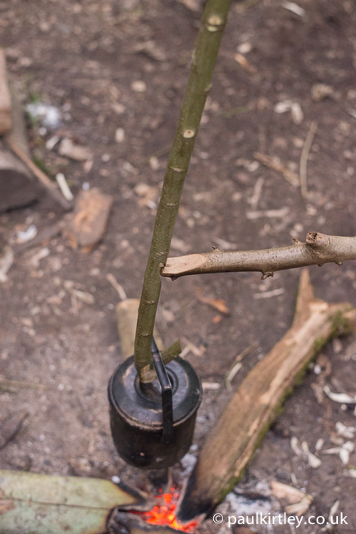
Suspending a billy can over a fire. 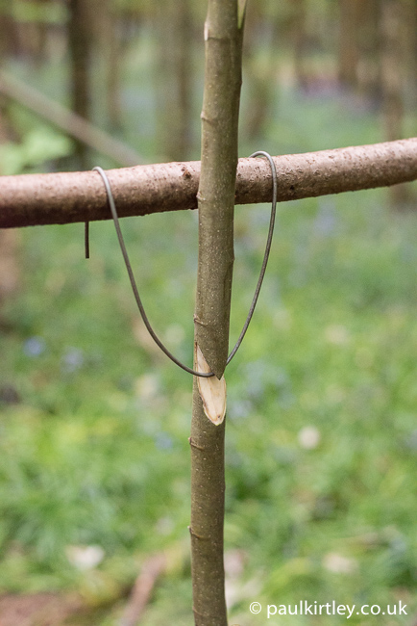
Using the notched stick in a multi-hanger rig. There are many ways of creating a loop of material. Here we used a piece of discarded fencing wire.

