Principles of fire making
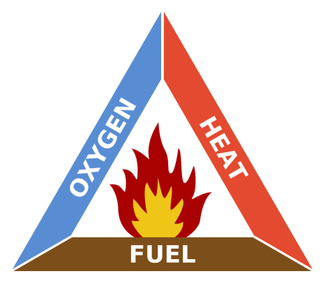
Take one away and your fire will go out.

Sources of ignition
Lighter
Matches
Feel rod
Flint and steel

Tinder Natural
Birch bark
Feather sticks
Fat wood
Reeds
Grass
Leaves
Tinder Man made
Cotton balls and Vaseline
Wax cotton pads
Fire lighters
Wax covered jute twine
Paracord
Hexi blocks
Tea lights

Tinder catches fire easily, but burns fast, make sure you have your kindling and fuel wood prepared before you light your fire.
Kindling
Small twigs and branches about the width of a pencil or less, Like tinder, kindling needs to be dry or else it won’t burn as easily.

Fuel wood
Fuel wood is what keeps your fire hot and burning. Contrary to popular belief, fuel wood doesn’t have to look like the huge logs you use in a fireplace. If you go too big, it’s going to take a long time for the wood to catch fire. Look for branches as thick as you fingers, building up to branches as thick as your wrist or forearm.
General tips
When gathering wood for a fire, collect wood that snaps and breaks easily, dry dead standing avoid wood off the ground. Collect twice as much tinder and kindling as you think you’ll need. You’ll be surprised how fast you’ll go through tinder and kindling when you’re starting your fire.
Lay Your Fire
There are several ways to lay your fire. Here are three of the most common types of lays.
Teepee Fire Lay
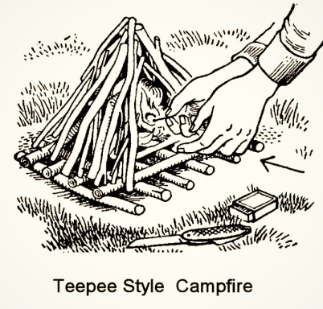
Lean-to Fire Lay
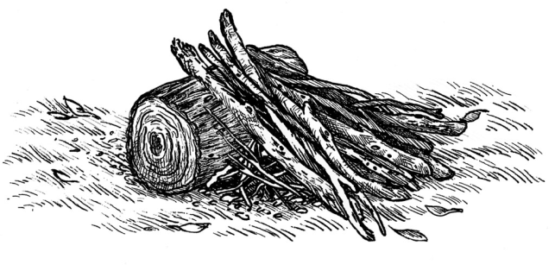
Log Cabin Fire Lay
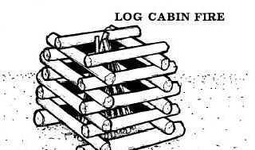
Regardless of which lay you use, having a base of wood lifts the fire of the damp ground. Ensure that you clear the surrounding area to avoid your fire from spreading. Consider digging a shallow fire pit or surrounding the fire with stones.

